VIDYA NIKETAN PUBIC SCHOOL

Annual Report
  - 2020-2021
“Learning gives creativity, creativity leads to thinking, thinking provides, knowledge and knowledge makes you great.”
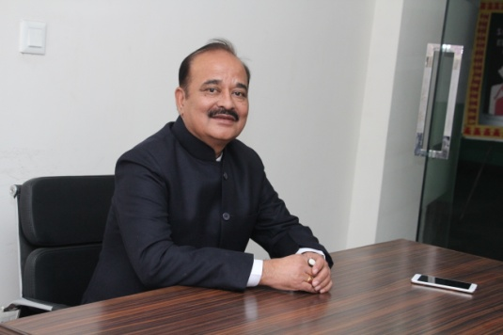
Chairman (Vidya Niketan Public School, Nanakpura)
We are delighted that you are considering one of the best schools in South Delhi, Vidya Niketan Public School, Nanakpura for your child’s future. This esteemed institution over the years has honed a learning system that has been benchmarked across India for decades. VNPS aims to promote a system of the overall growth of our students by emphasizing education, skill-development, moral values, and social responsibility. We at VNPS believe that education should authorize students to soar high - socially, spiritually and morally. With our committed and knowledgeable faculty, global infrastructure, we strive to provide our children with the best environment to grow as an individual with the aim of a better world, since our children are our future. At VNPS, we have adopted a ‘Total Quality Management’ to make them learn moral values and ethics from an early age. These future citizens would thereby maintain the same standards of excellence in their career, life, and society. We invite you to join hands with us to nurture your child for a better future, for the country’s better future.
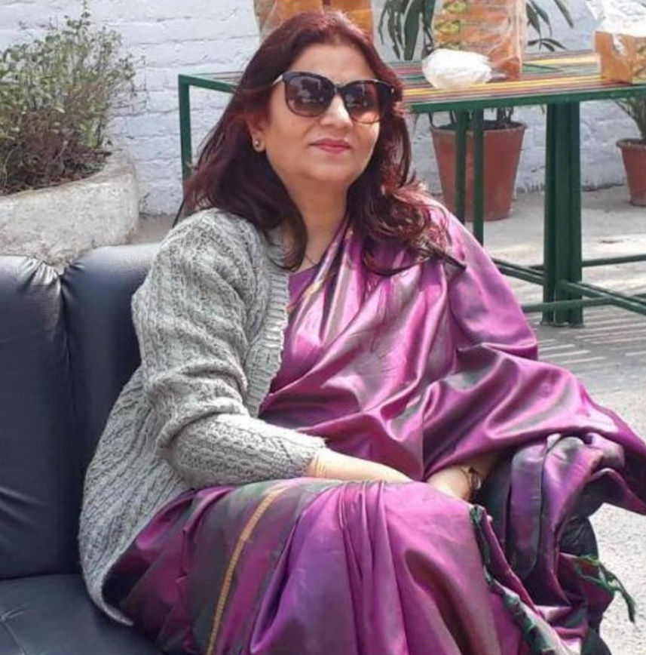
Shashi Sharma
Principal
(Vidya Niketan Public School, Nanakpura)
With the main aim of building a better tomorrow for children, our educators emphasize the overall growth and development of our students to enhance their problem solving, evaluation, solidarity, communication, creativity and innovation skills. We believe in a balance of pursuing academic mastery, gently urging students out of their comfort zone to aim for new challenges. We aim to make ‘future fit’ minds that are disciplined, ethical and respectful. We encourage our children to set some goals and provide them with the support and guidelines to achieve those goals. We at Vidya Niketan Public School believes that students and educators shall work together in harmony for the future well being of our children that will set course for a better world for everyone alike. To support and guide our children’s learning, we call for the support of our dear parents in ensuring that our children:
- Attend school daily and arrive on time.
- Complete all homework assignments given by teachers.
- Read books and newspaper daily to develop a love for reading and to enhance literacy skills.
- Share school experiences with you.
- Adhere to proper decorum.
- Eat healthy food and avoid junk food to promote better health and well being.
- At Vidya Niketan Public School, our students are encouraged and guided to become a responsible, socially aware and humane individuals working for the betterment of the society as a whole.
Our founder chairman had the desire to create a dynamic environment to bring out the best of every student in a holistic manner. With learning’s focused on the complete development of a child, Vidya Niketan School envisions to be the foundation for creating wise leaders rooted in their ethnicity and culture to create a better future for all.
His mission is to achieve the holistic development of students through an excellent academic and physical environment that is conducive to learning, developing creativity, and exploration. To create healthy, strong, disciplined, bold, and competent citizens who will work for the betterment of the Nation.

TRANSPORT FACILITIES
The school provides a bus transport facility covering all major parts of Delhi. Rest assured your ward will be picked up and dropped back at the right time every day. A teacher is always present in the bus ensuring the safe pick and drop of students. Transport charges are levied as per the locality and the distance from the school. Please note, one month notice is mandatory before withdrawing your child from the school bus transport facility.

LIBRARY
Vidya Niketan public school has a well-stocked library so that our students can improve their reading skills as well as develop a habit for reading. Students can borrow books from the library to read back home. The school library boasts of a large collection of books catering to all niches such as reference books, encyclopaedia, storybooks, novels, and magazines . News books are added every month so that the students can keep on learning as well as stay connected with the latest trends. The students of class IV onwards are issued books that they must return within a week. Delay in return and loss/damage of books are fined.

SPORTS AND GAMES
With obesity becoming a major cause of problem in today’s generation, physical education is given importance wherein children are motivated to take part in sports of their liking and sports events that are held in the school. With a certified P.T teacher students are encouraged to play their favourite sport and stay active and healthy. Extra co-curricular activities in school include badminton, basketball, cricket, football, yoga, karate etc.

MUSIC AND DANCE
Developing new skills goes a long way in paving a bright path for our children career. At VNPS, students are encouraged to develop their passion into a hobby which if way want later can pursue as their career. There are compulsory co-curricular subjects. These include vocal music, both Indian and western along with classical and folk dance. The school holds classical dance classes in the evening twice a week.

COMPUTER EDUCATION
With the trend shifting to Digitalization of almost everything, computer knowledge is completely necessary in order to stay updated with the current world. Vidya Niketan Public School has specialized staff to teach students computers in well-equipped computer labs. The young children are encouraged to play computer games and experiment with computer graphics, gradually acquiring proficiency and skills in using computers as day tools for enhancing the reach of their minds.

PICNIC EXCURSIONS AND TOURS
Students at Vidya Niketan are taken on tours to the heritage sights of India to make them learn about the rich history of our beloved nation, to make them aware of the reputed personalities of India. Picnic excursions and tours are organised annually for our students while ensuring complete safety.

OTHER ACTIVITIES INCLUDE
We must encourage our children to follow their passion since no two children are the same, one may be good at dancing while others may be good at singing. We must motivate them to develop and polish their hobby and turn it into their career. For a person is always successful if he/she chooses his passion as its career. At Vidya Niketan Public School, students are encouraged to take part in storytelling, declamation, drama, cooking, elocution, debate, dance, singing, theatre and many more activities.

MARTIAL ART
The peace of mind that comes from knowing that you are able to protect yourself and others. Our school has inculcated Martial art from the last two years. Through this art form, children learn self-defence. Trained martial arts trainer teaches proven techniques with a focus on self-defence and awareness training for any situation to all the classes.

SMART CLASS
Extra marks Education PVT LTD helps the school to be constantly creative and provides the best gaming and teaching tools so that they are at per with the latest development. These smart-boards provide teaching and learning aids to make studies simple. These smart learning classes (teachings aids) are of immense benefit to the teachers and student as they flow in an easy, receptive manner. This technology enables us to provide lesson plans and study modules as per the curriculum along with strong infrastructure support.

SECURITY
VNPS takes utmost care of its students while they are on the premises. The school is covered under the surveillance of 32 CCTV cameras for all-round security and security guards are present at the entry and exit point of the school ensuring no anti-social element enters the school premises. All these facilities enable Vidya Niketan Public School to be considered as one of the best schools in South Delhi Nanakpura Province.
VNPS

ONLINE EDUCATION
The academic year 2020 – 2021, faced a very challenging time which brought the world to a complete halt with the Corona pandemic and with lockdown all over the Nation. This isolation was unique and unprecedented event in our lives. It had become imperative to stay at home and we had to decide as to how meaningfully we could utilize our time. In these hard times, we had to maintain positivity and high morale.
We all had faced a completely unprecedented crisis due to the spread of corona virus all around the world. However, this time had taught us how to build foundations of resilience to face difficult events in future. Conducting exams was the biggest challenge. Students were sent question papers through WhatsApp and Google classroom and they had to solve them under the supervision of their parents . Std. I to Std. VIII had to be promoted to next grades. We believed that our students would have solved the final exam papers at home honestly. This was “Self Evaluation”.
As per our daily routine, we would begin our sessions with meditation audio every day.
Coming to the academics section, we had already sent the text book images of few lessons, for all subjects of Std. I to Std. X. Teachers uploaded the study material of two subjects daily for Std. I to V and of three subjects daily for Std VI to IX on WhatsApp and Google classroom . This material will be sent on the previous day by late evening so that on the next day the students could start their studies on time.. This study material included PPTs, videos, audios which was sent to the students in parts, explaining the first unit or lesson part by part. Every subject was repeated twice a week. This was followed by notes, question-answers, worksheets, home assignments, activity sheets, etc.
“All work and no play makes jack a dull boy” so after study time, students were asked to remain engaged in household activities, reading books, making art/craft articles and also in doing physical exercises like yoga/asanas at home. As our usual practice, we also sent some inspirational videos in between upon which parents could you have good discussions with their children.
Our teachers not only covered the scholastic areas but also the co-scholastic areas like dance/ music/art. Our physical instructors kept students occupied by sending them videos on health and fitness and easy exercises that could be done at home.
Our students have responded well to online classes and have been getting their doubts cleared. Since the parents were kept in the loop from time to time, through mails and messages they were well aware of what the school is trying to do to cope up with this change.

Assessment of Learning gaps:
During online session verbal assessment by asking questions was conducted by the teachers . The various tests assigned in the form of Google forms gave an analysis of the performance of the class and question wise mapping . The teacher was able to map the learning gaps. Weekly test and activities were conducted to monitor the teaching learning process . The periodic test was conducted online to assess whether the learning objectives are achieved or not. Question wise feedback was provided to the students during periodic test .Virtual interactions were conducted to understand the learning gaps from the feedback given by the parents.

Online Participation in various competitions - 2020-21
In the academic year 2020-2021, our school participated in various online quizzes, pledges, webinar and competitions during the pandemic and received achievements in the same.
s.no | class | Name of the student | activity | position
1 | 7 | Nidhi pandey | EBSB an interschool completion | -
2 | 7 | Sanskriti thakur | Quize on covid 19 | -
3 | 7 | Nidhi pandey | Effect of lockdown on biodiversity | -
4 | 8 | Roshmi goswami | Lets go local  EBSB an interschool completion | -
5 | 9 | Raunak raj | District level, kala utsav | 1st position

During this serious pandemic, our school took part in various Fit India Movement activities. The students sent videos and pictures while exercising and jogging in the parks, all the while taking necessary precautions for covid-19.

